 

Marketing Lead Instructions for PC or MAC

Look for an email from your contact with Avid WebWorks.  
Click the “Join HubSpot” link to setup your account

Log into your HubSpot account. Setup 2FA authentication if requested (cell phone is easiest).

Click on “Contacts” in the top left and navigate to “Companies”.  
  
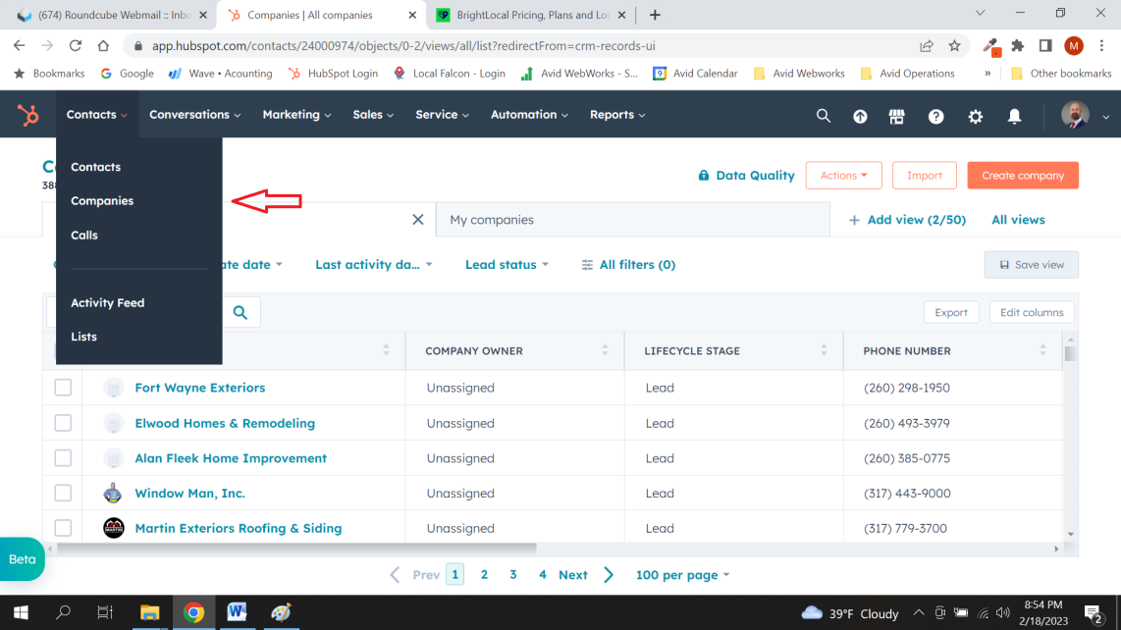

You should now see a list of companies that has tabs across the top. Click “+ Add view” at the right side. Scroll down and click “Company View”. Now click the x to remove “All companies” view at the top. Arrange “Company View” on the left and “My companies” on the right. You can do this by clicking and dragging them. This will make it easier to view when working on leads.  
  
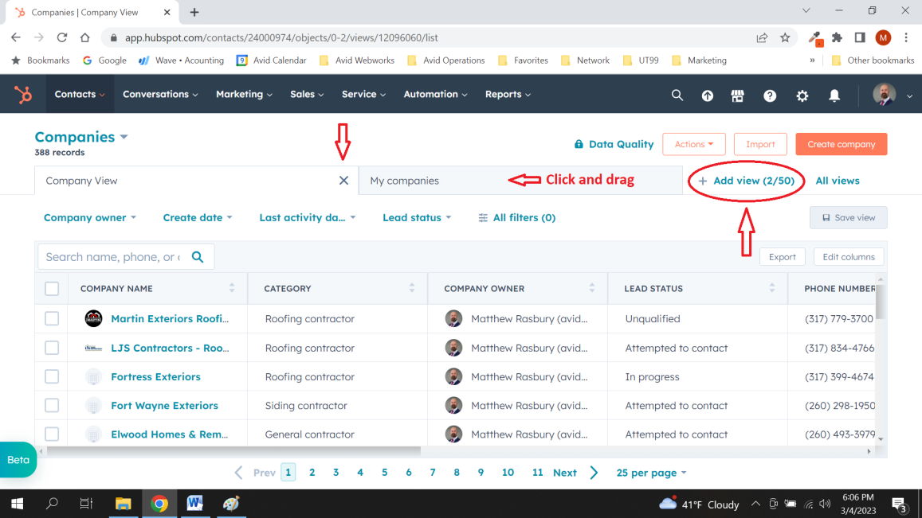

Begin marketing:

The first step is to allocate the lead to you. Click on the box in the column named “Company owner” next to the business you are going to prospect select yourself and click “Save”.  
  
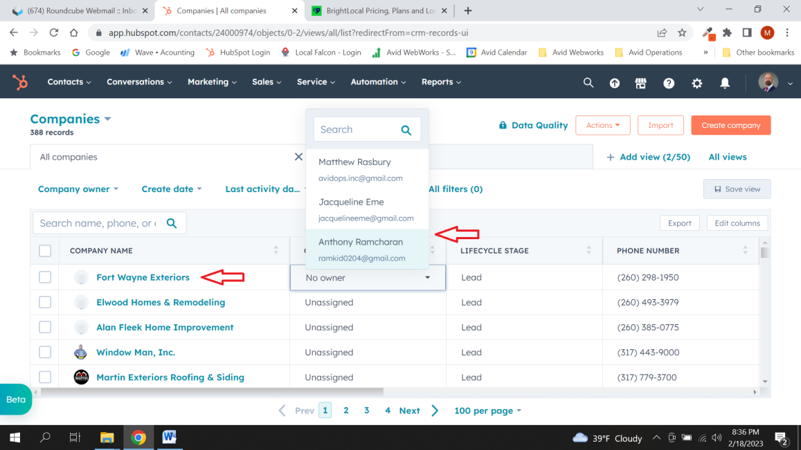

Next, click on the company name on the left. Once you are in the business detail page you will see orange icons below the company name. The ones you will be primarily concerned with will be the last 2. These can be used to schedule and apt and log calls. Don’t forget to click “Save” when prompted.

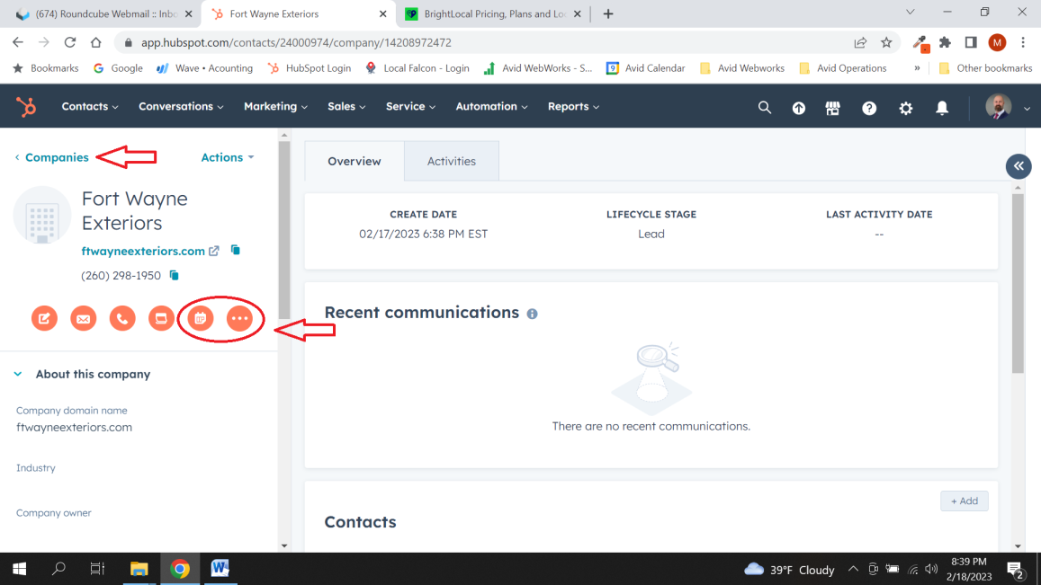  
  
Once you are done, click back or click the “< Companies” in the top left and return to the list.

Now, change the “Lead status” next to that company to whatever the outcome was and click “Save”.  
  
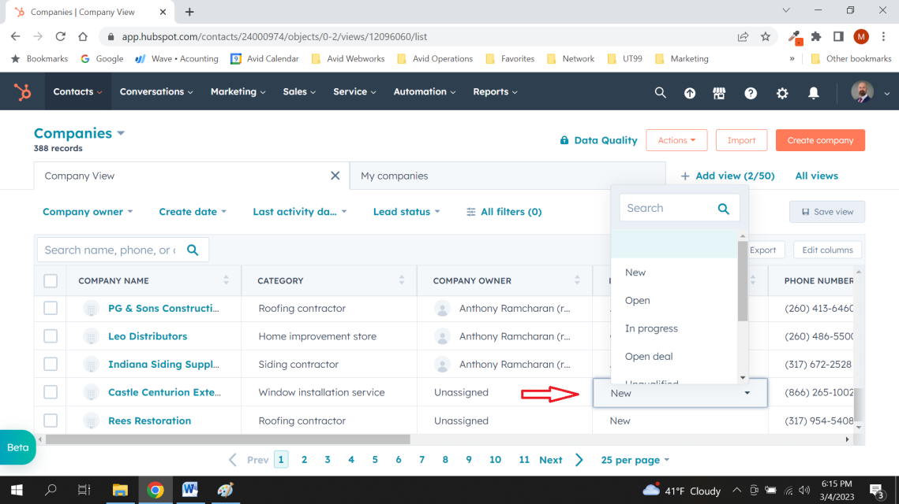

Lead – new lead waiting for marketing agent  
Opportunity – Call back, made appointment or scheduled a screen share  
Customer – New customer or subscriber  
Not Interested – Services declined or not needed  
Attempt Made – Not available or bad lead

The layout for mobile devices is slightly different but this should give you a good understanding of how to arrange and use the HubSpot dashboard to start marketing.

We will sync successful transactions with HubSpot “Company owner” and “Lead Status” to verify marketing payouts Sunday through Saturday.

Commissions will be paid through Gpay (Google Pay) the following Friday.

Gpay is available for Android and Apple

PC or Mac go to: pay.google.com

For more information email me at: m.rasbury@avidwebworks.com